**Lab4 – Installing Apache in Ubuntu Virtual Machine - Azure**

**Topology**

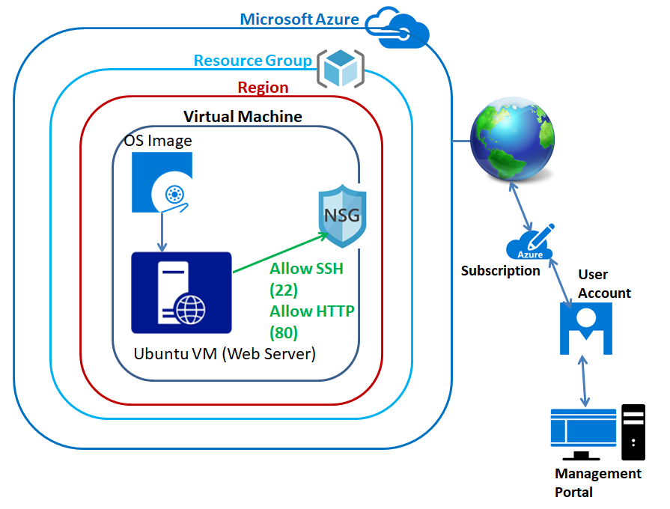

In Azure portal, click **“Resource groups”** in left side panel.

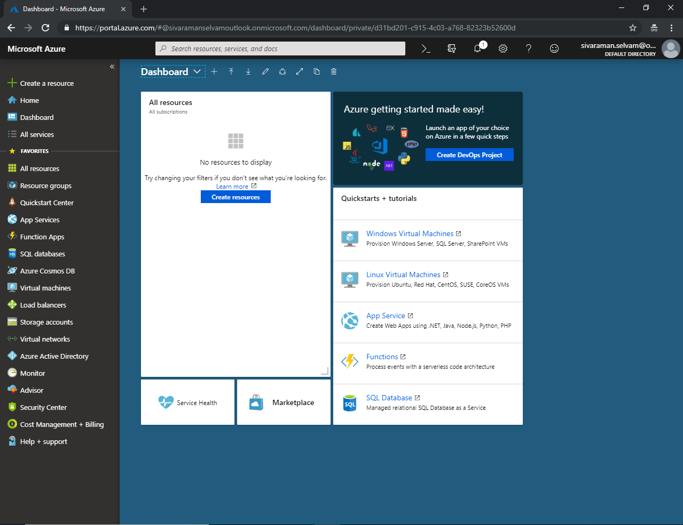

**In “Resource groups” click “Add”**

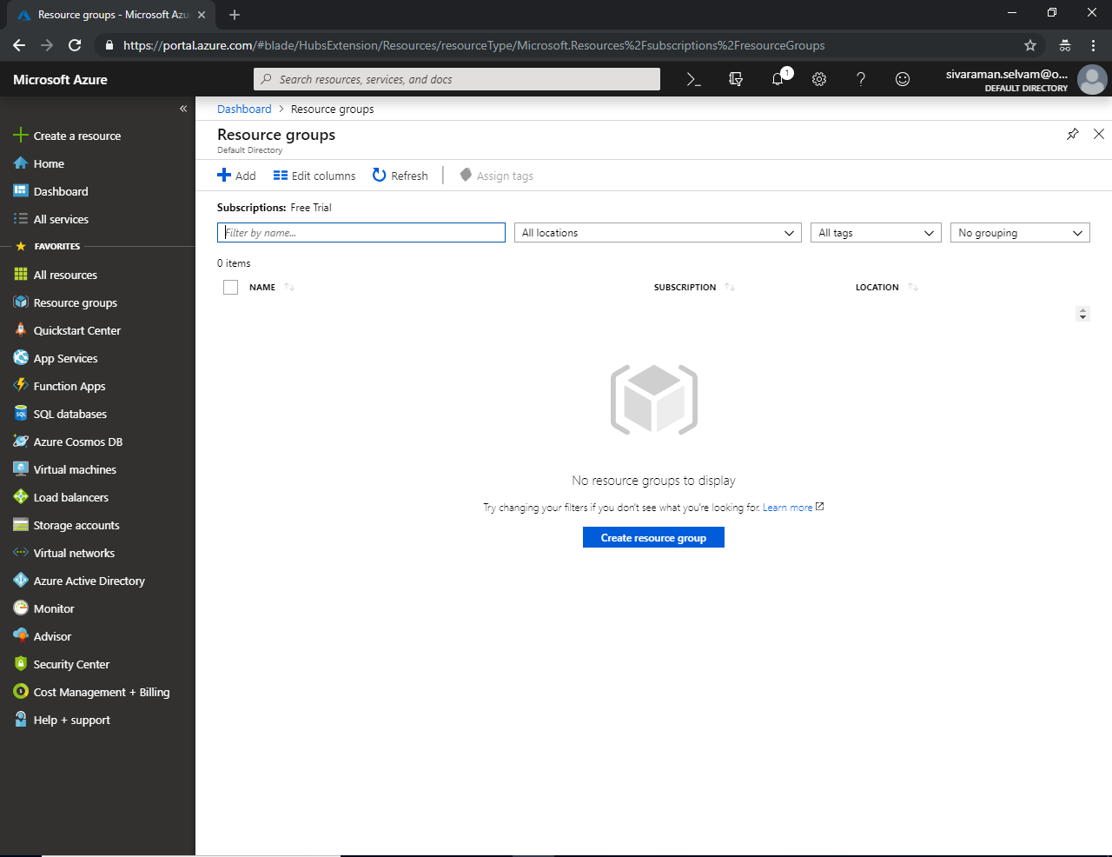

While creating **“Resource group”**, type Resource group name as **“SansboundAzureClass”**.

Click **“Create”** to create the Resource Group.

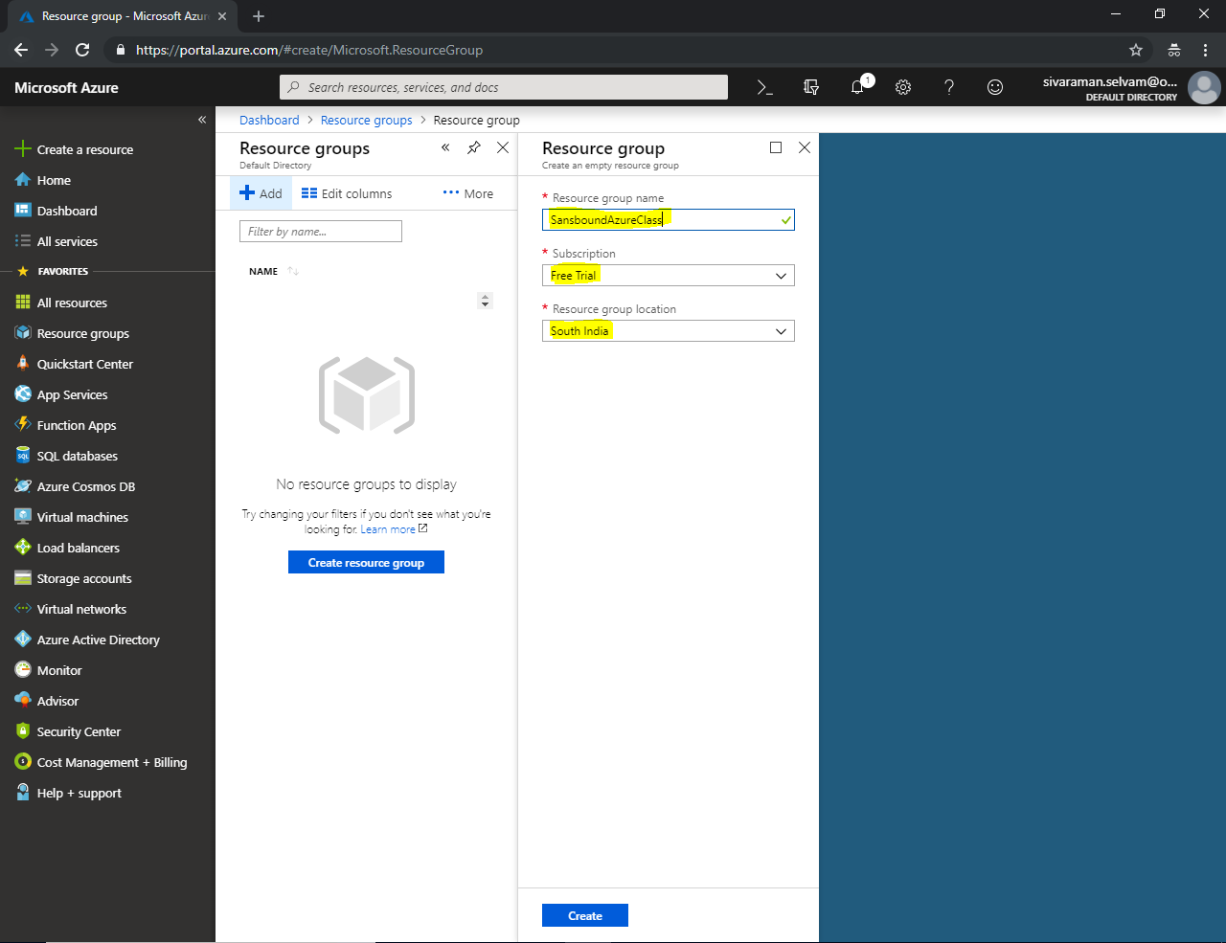

Click **“Refresh”** to review the **“Resource group”** which you have created.

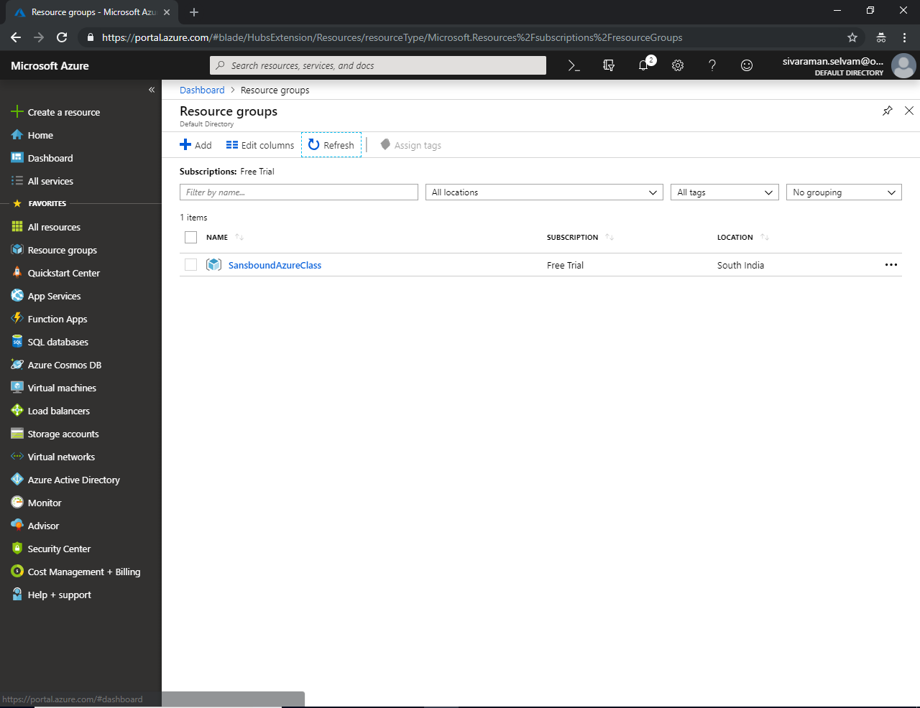

Click **“Virtual machines”** in left side panel.

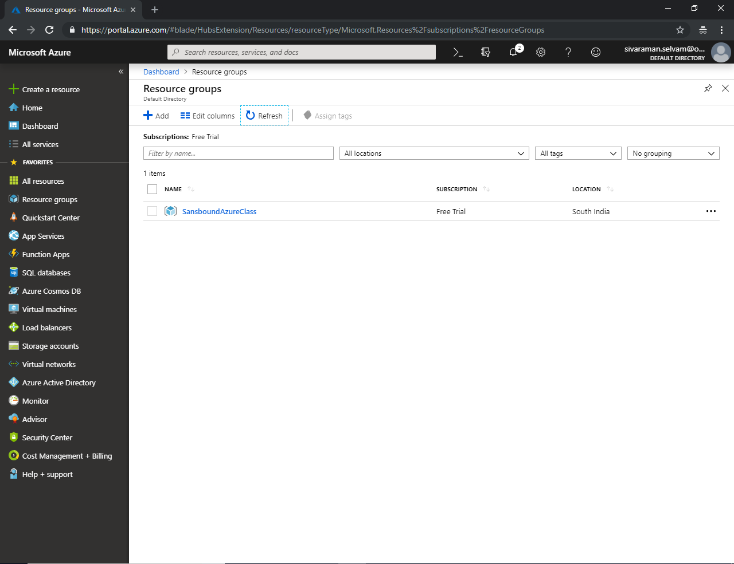

**Click “Add” to create new virtual machine.**

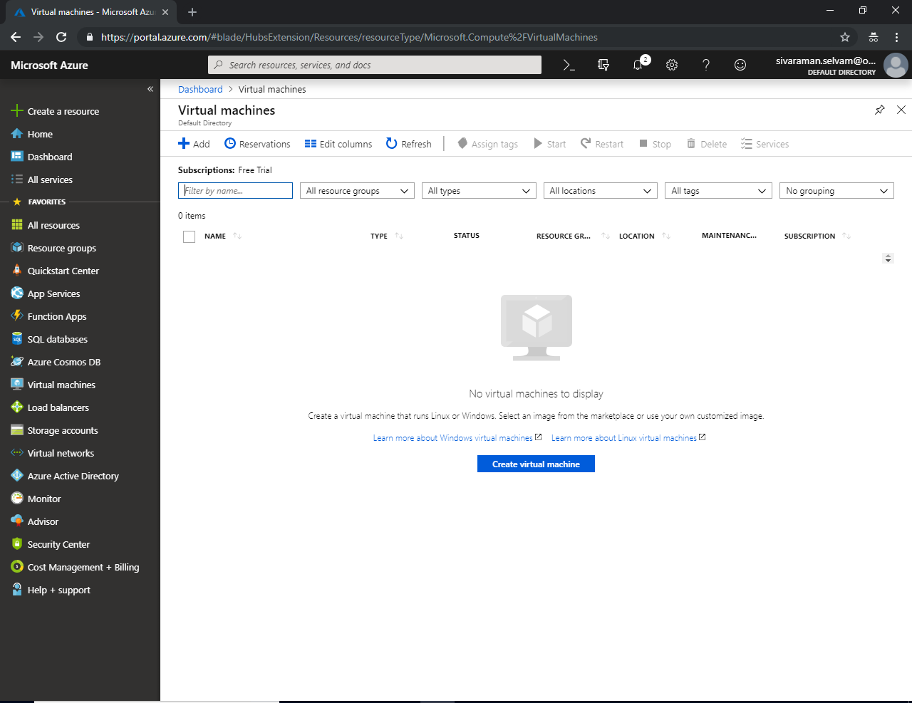

In **“Subscription”** select as “Free trial”.

In **“Resource Group“** should be select as **“SansboundAzureClass”**.

In **Virtual machine name**, type the virtual machine name as **“UbuntuVM-WebSvr”**.

Select **“Region”** as **“South India”**.

Select **“OS Image”** as **“Ubuntu Server 18.04”**.

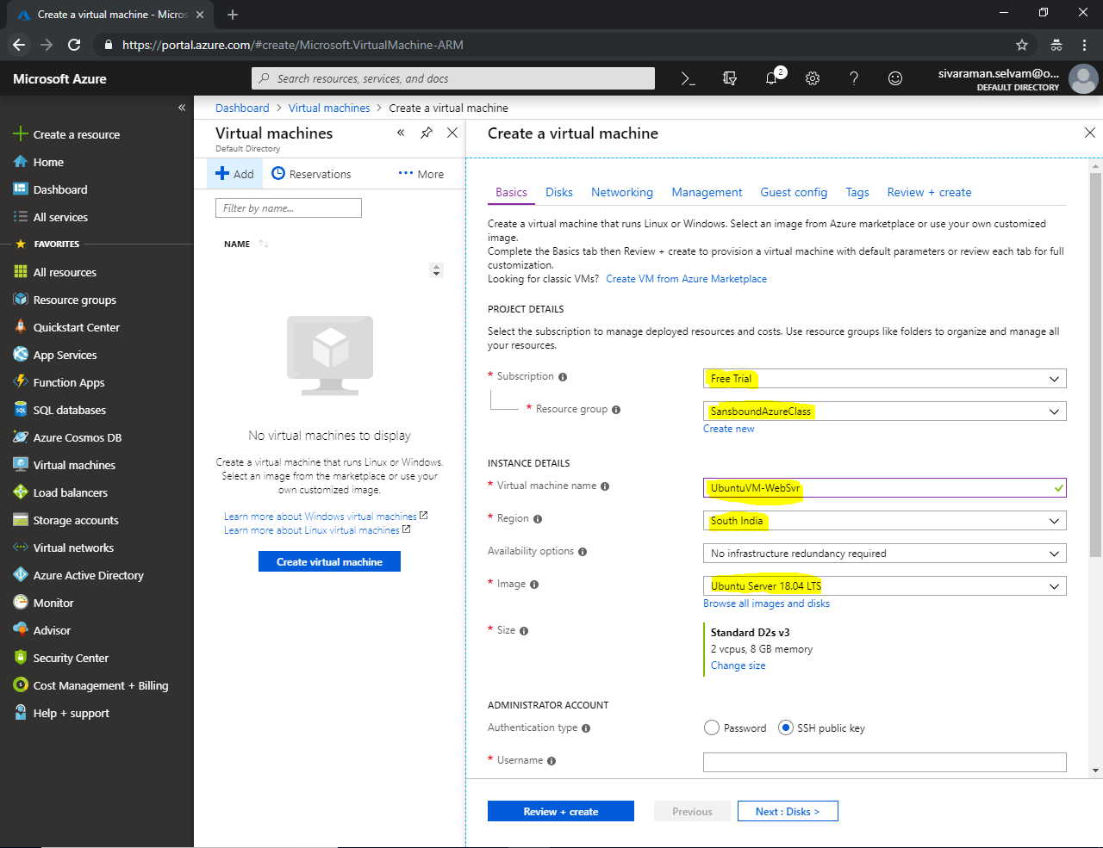

In Virtual machine size by default **“Standard D2sv3”** has been selected. Click **“Change size”** to change the VM Size as **“Standard B1s”** which is eligible for Free trial.

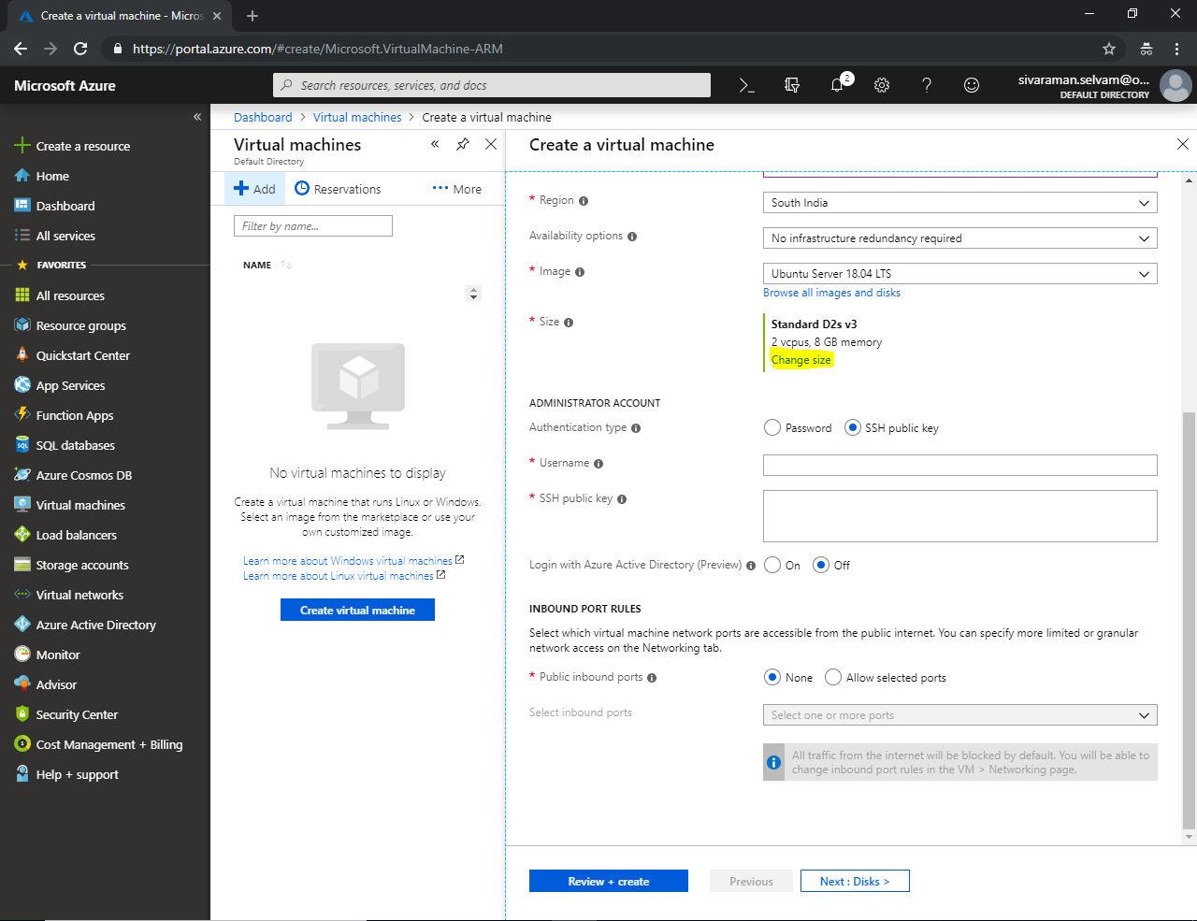

Click on **“B1s Standard”** and click **“Select”** button.

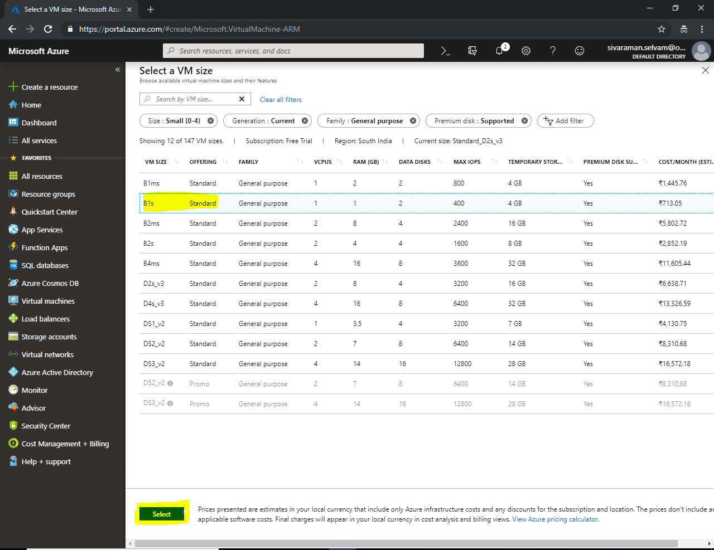

Ensure that **“Standard B1s”** has been selected.

In **“Administrator Account”**, set authentication type as **“Password”** by click the option.

Type the user name which you have required to access the Ubuntu server.

Type your own password to access the Ubuntu server.

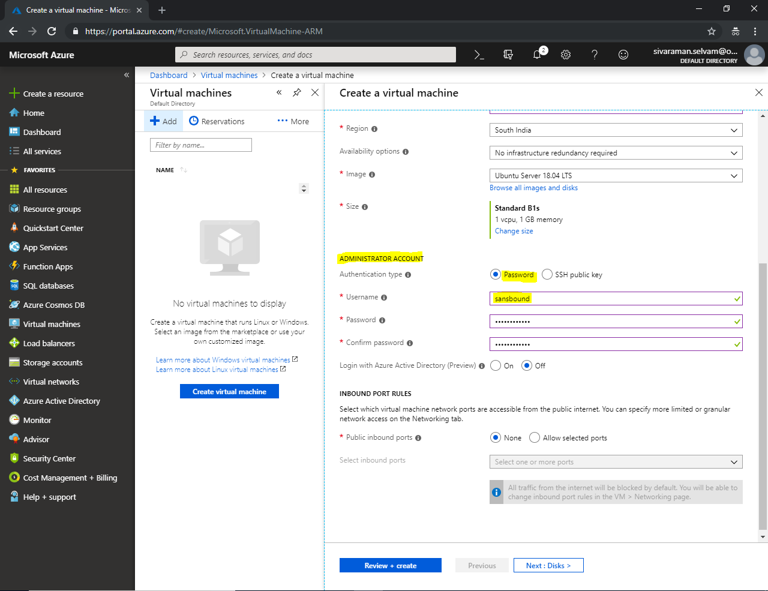

In **“Inbound Port Rules”**, set Public inbound ports as **“Allowed selected ports”**.

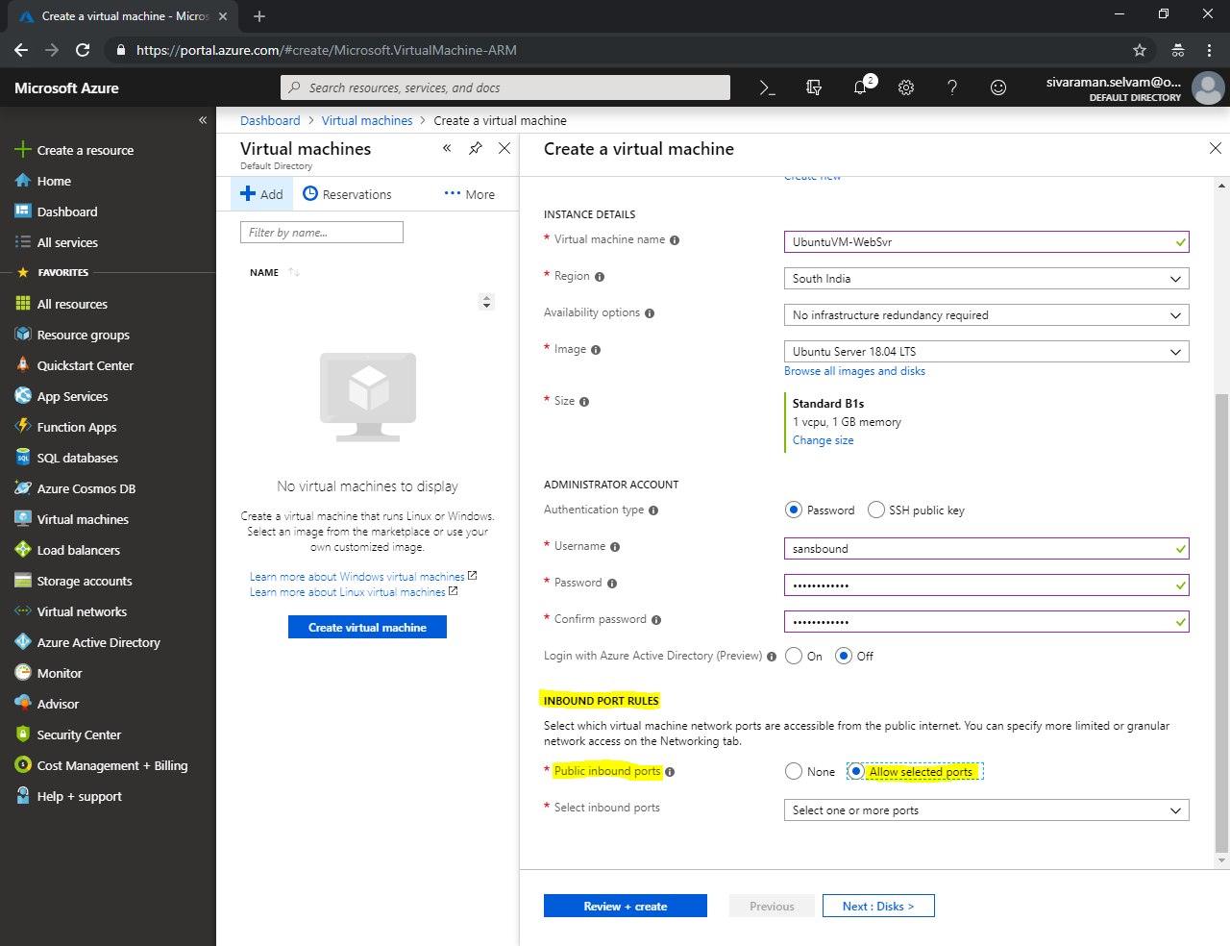

In **“Inbound Port Rules”**

In **“Select inbound ports”**, click the drop down list and select **“SSH (22)”** to access the Ubuntu server through SSH remotely.

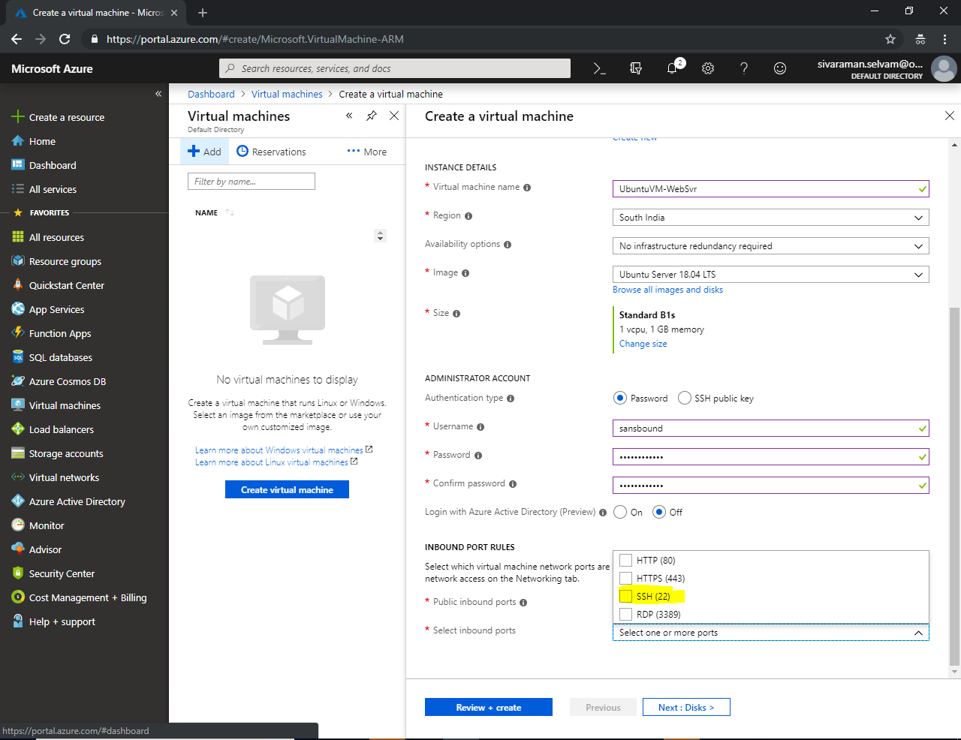

In **“Select inbound Ports”** you are able to see that **“SSH”** is selected.

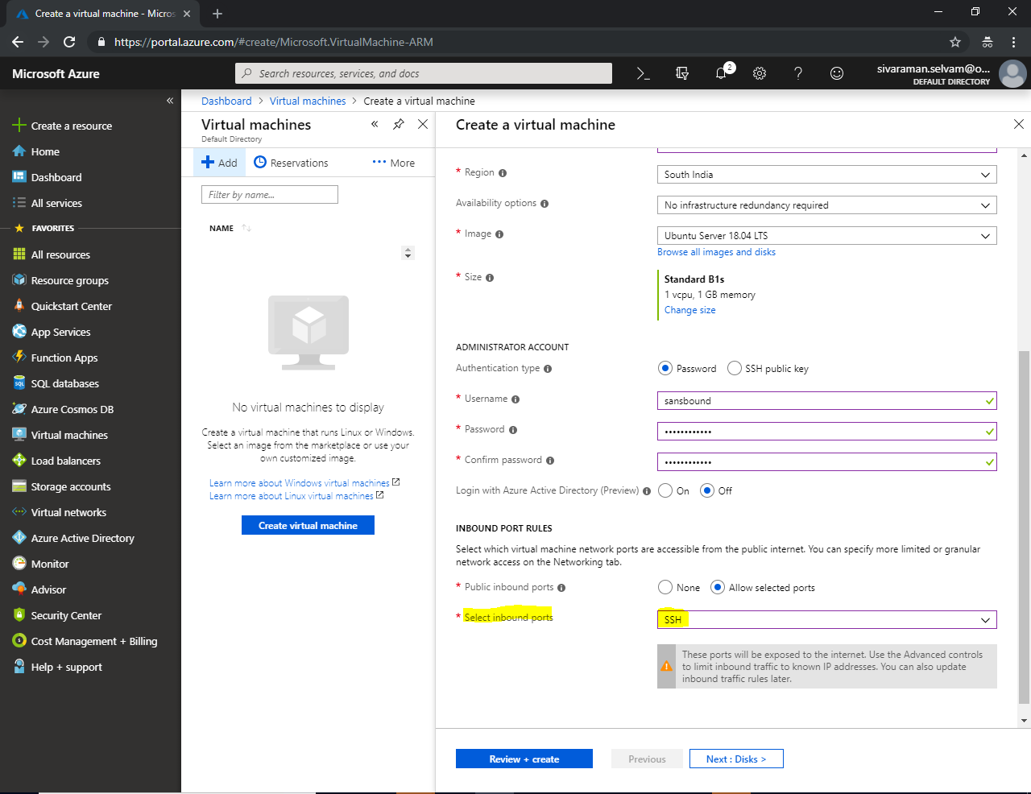

In **“Select inbound ports”**, click the drop down list and check **“HTTP (80)”** also. Because, we are going to install **“Apache”** in Ubuntu server.

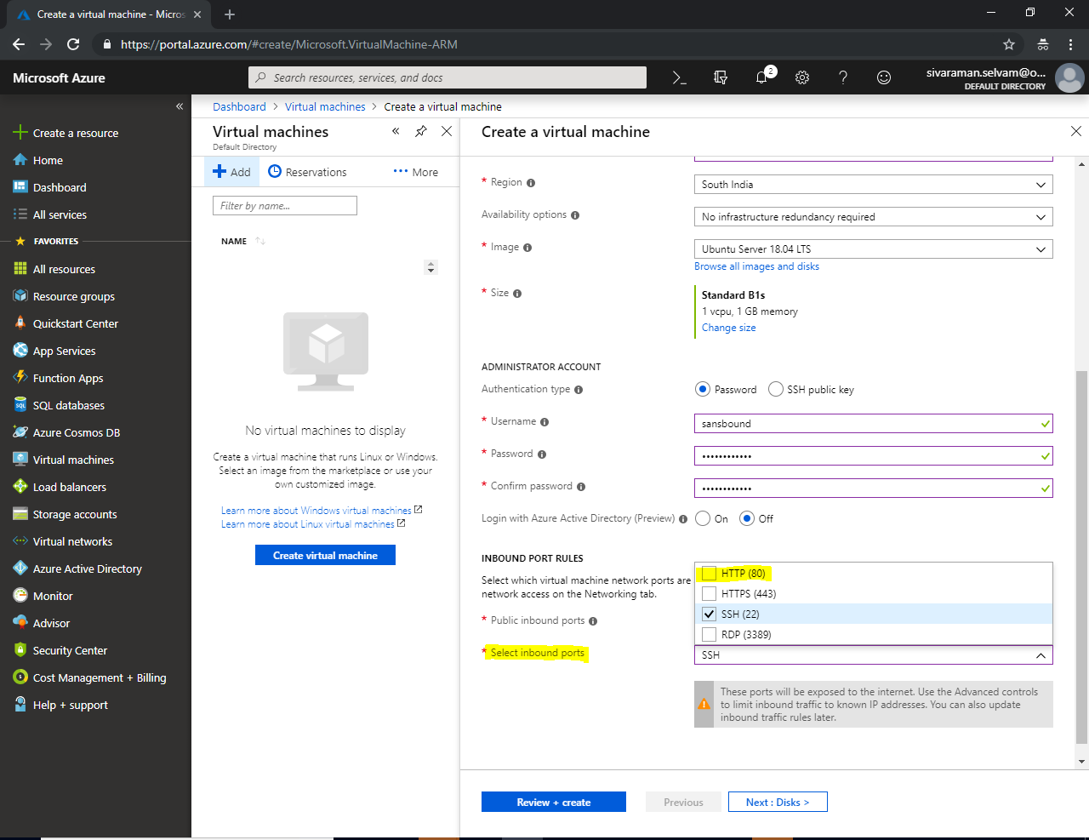

Ensure that **“HTTP (80) and SSH (22)”** ports are allowed to connect from **public network**.

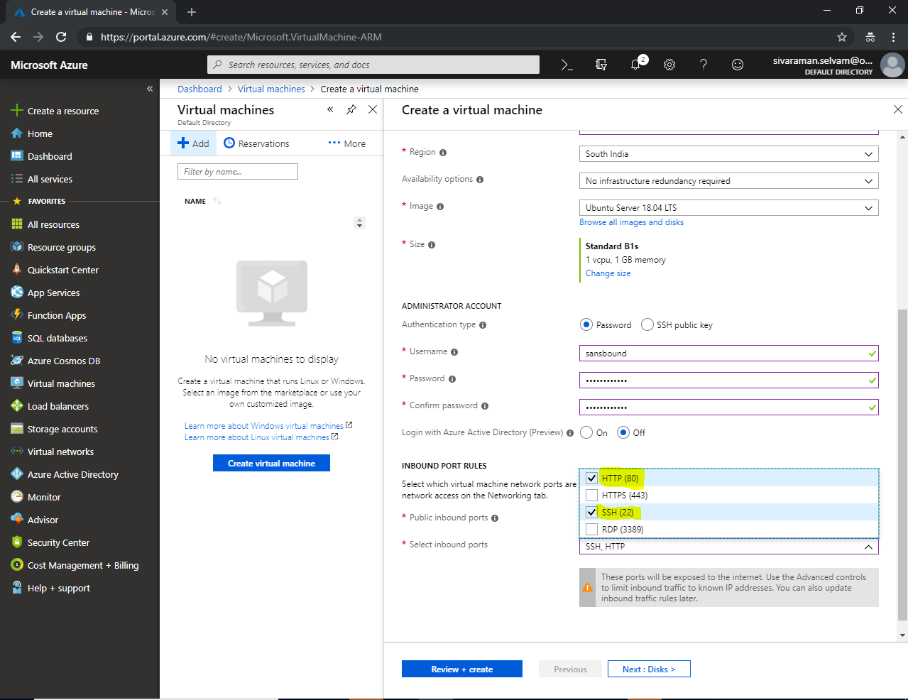

Click **“Review + Create”**.

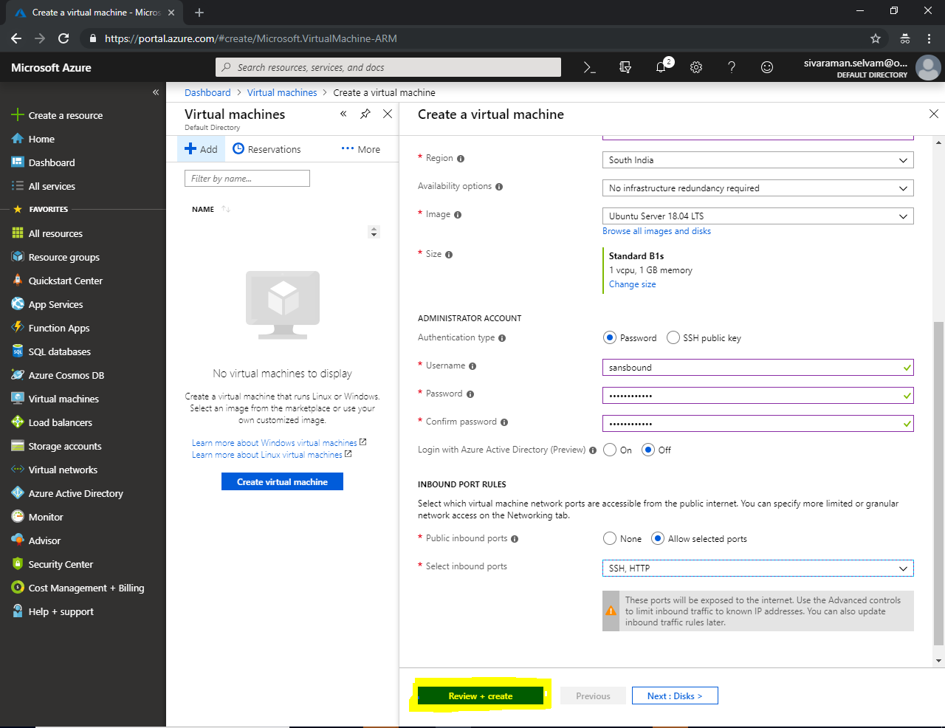

Click **“Create”**.

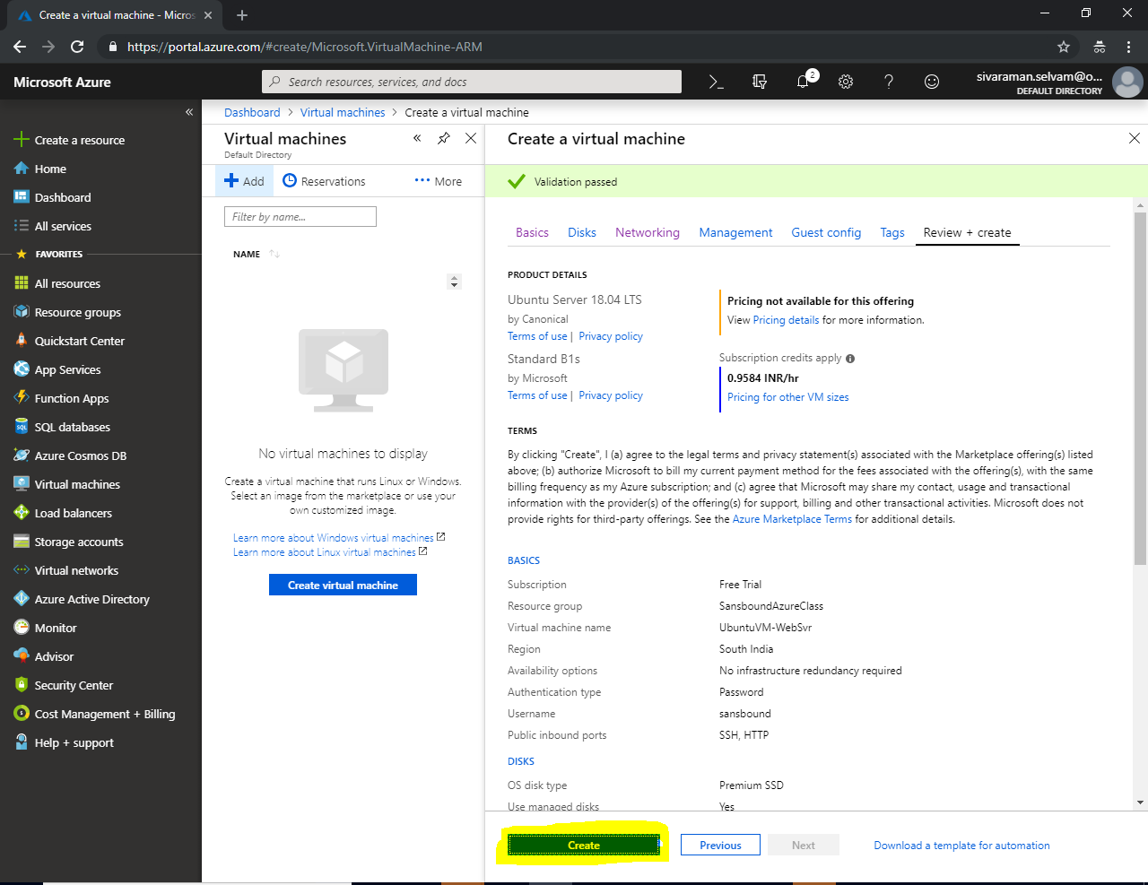

Your deployment has been successfully completed.

Click **“Go to resource“**.

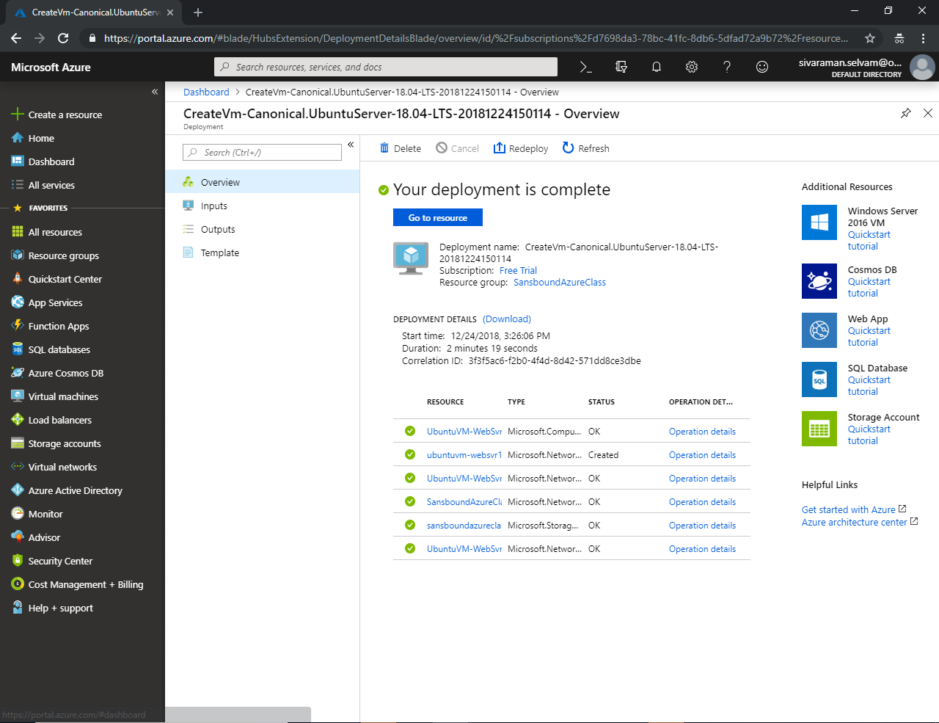

Kindly note the Public IP address which has required to access the Ubuntu server from public.

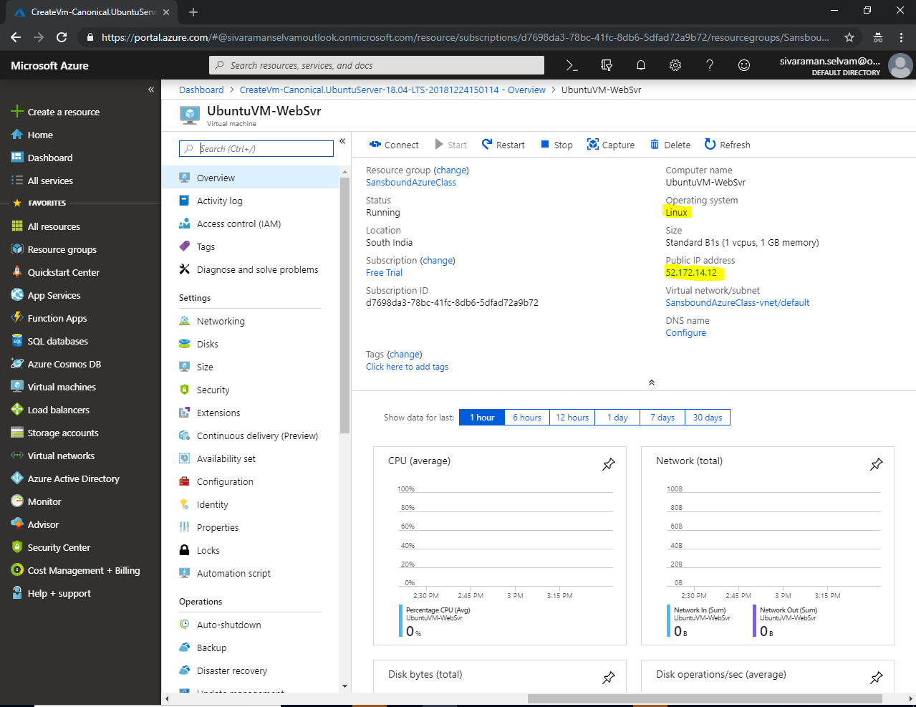

Download the putty from <https://www.putty.org/> and install it and launch the “putty.exe”.

In Putty, type the Public IP address of Ubuntu server and click “Open” to connect.

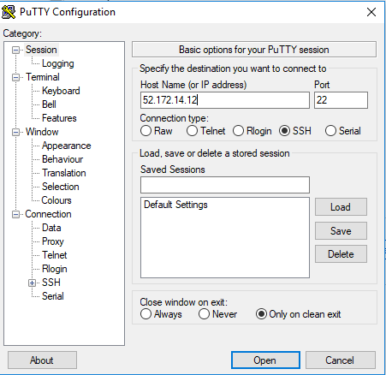

Click **“Yes”.**

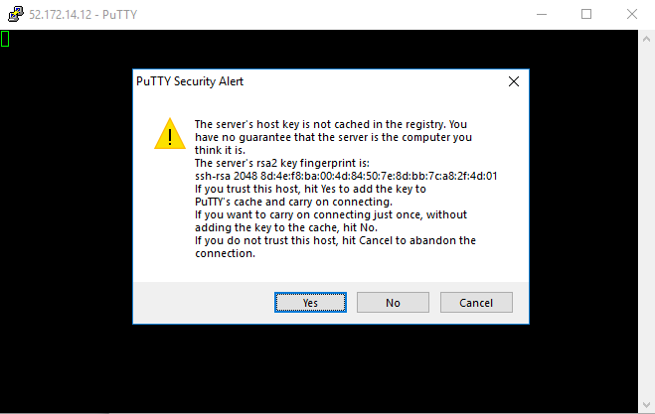

Type Username as “sansbound” and press “Enter”.

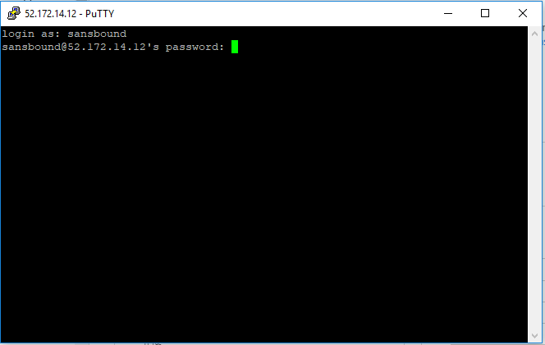

It will require password, type the password which you have specified while creating the Virtual machine in Azure.

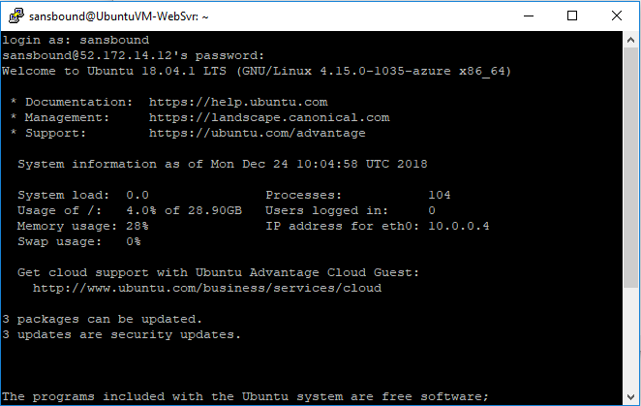

Now I have required to login as root account.

Then type “sudo –i” and press “Enter”.

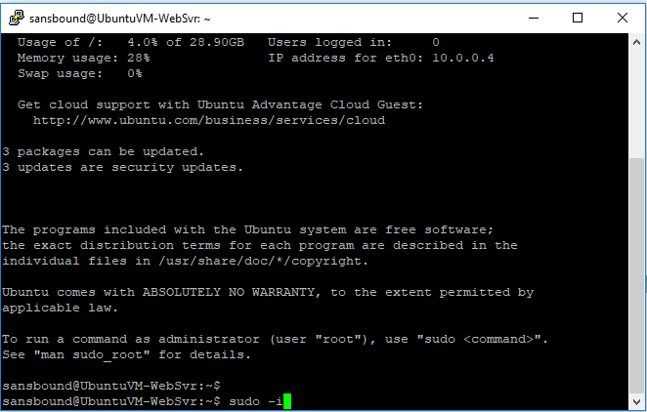

Now you have successfully logged in as a root user.

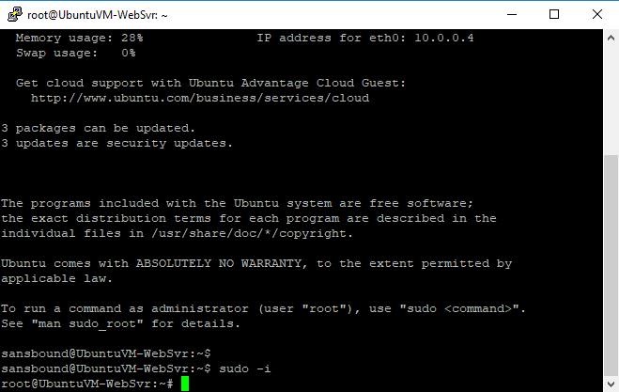

Type “apt-get –y update” and press “Enter”.

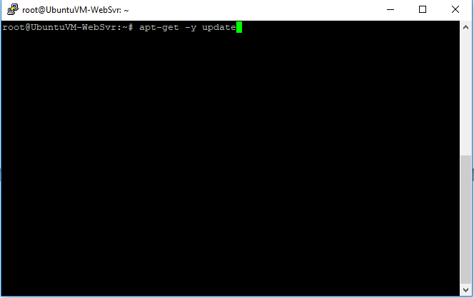

Now packages has been updated from internet.

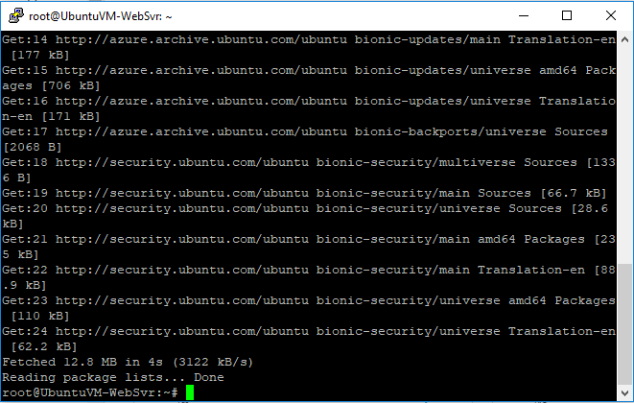

Type “apt-get install apache2” and press “Enter”.

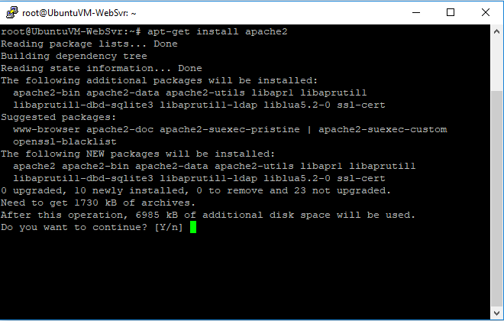

Type **“Y”** and press **“Enter”** to install package.

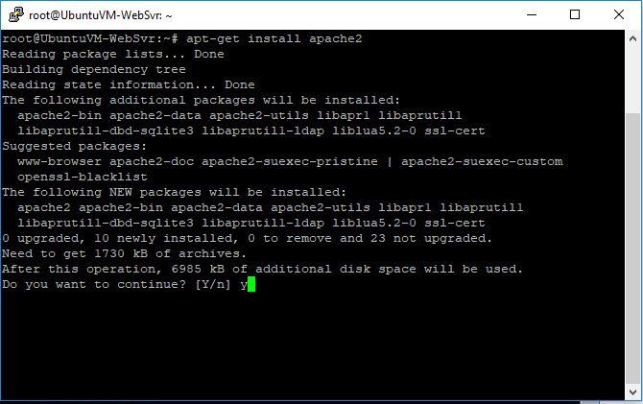

You have successfully installed the apache.

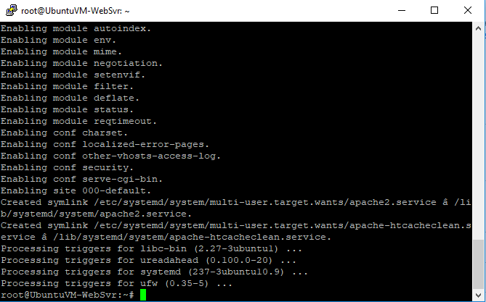

Type the IP address of Ubuntu in browser at your local machine. You have successfully got the default web server.

